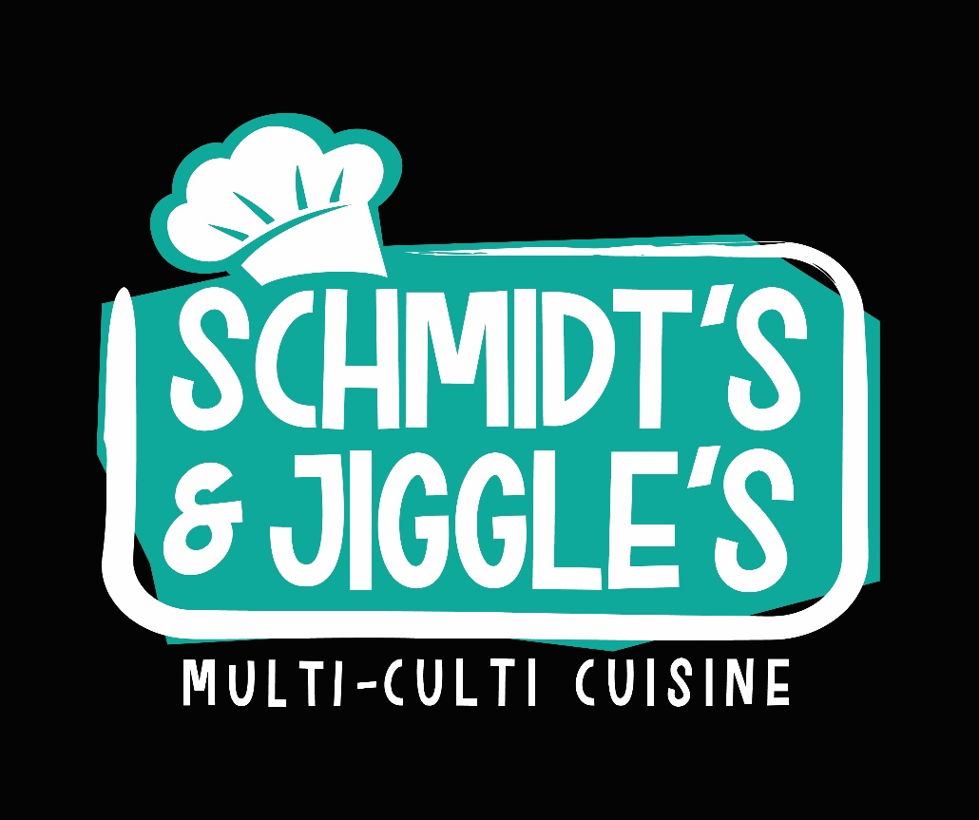

ENTREES

**Schmidt’s Street Tacos $7.00**

3 pork tacos with onions, cilantro, pickled red cabbage, house made avocado crema

**The Italian Stallion $7.00**

2 all-beef Italian meatball sliders stuffed with mozzarella and dredged in marinara, served on sweet Hawaiian rolls

**Buttah Chicken $8.00**

Middle Eastern dish typically known as “butter chicken.” Sautéed chicken breast swimming in a creamy tomato-based blend of various herbs and spices atop a serving of basmati rice.

**Quarternese Dumplings $8.00**

Japanese style pot stickers with a pork and beef filling, topped with onion and a mild Sriracha sauce. Served over rice.

BREAKFAST

**Mimi’s Buttered Biscuit $3.00**

Southern-style homemade buttered biscuit with choice of bacon or smoked sausage.

Add cheese .50

Add scrambled egg .50

**JAPANCAKES $5.00**

Thick, fluffy pancakes topped with fresh fruit and a dollop of whipped cream. Served with a side of syrup.

**The Grecian $7.00**

Omelet stuffed with spinach, onion, feta and mozzarella cheeses. Topped with a seasoned mix of sliced olives, artichoke hearts, and diced tomatoes.

PICK-A-DIP

**Choice of any dip listed below with a side of tortilla chips.**

**$3.00**

**Abuela’s Guacamole**

**Hawaiian Mango Pineapple Salsa**

**The Mexi-Corn Dip**

DESSERT OF

THE DAY

**Various desserts made fresh each day.**

**Ask about today’s sweet treat special!**

DRINKS

**Coke, Diet Coke,**

**Sprite, Bottled Water $1.00**